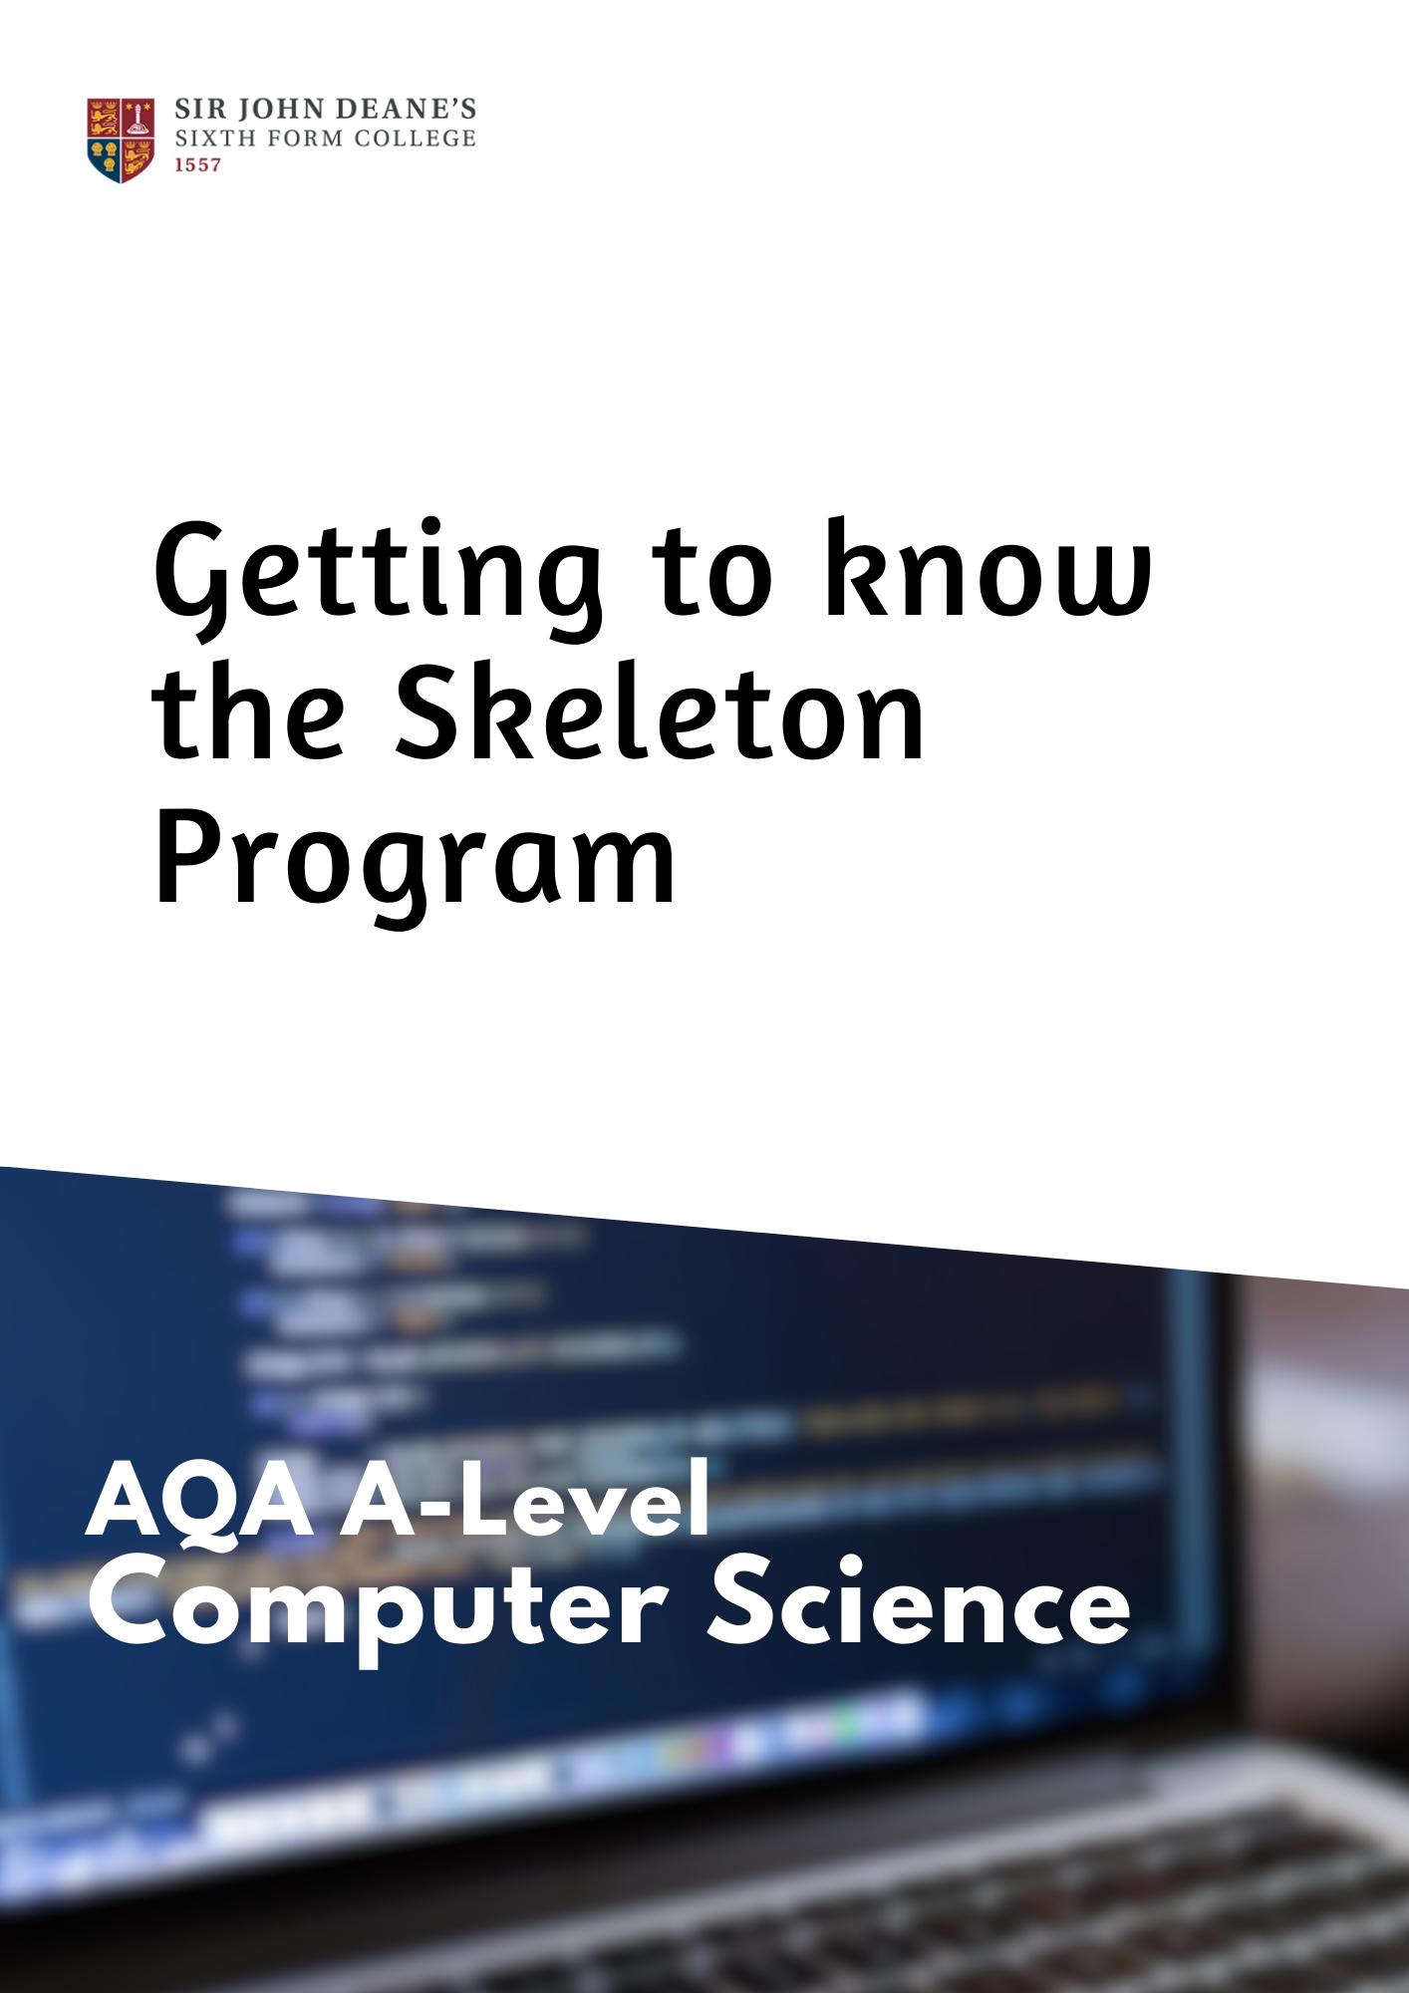

Introduction

Information
A Skeleton Program is provided separately by your teacher and must be read in conjunction with this Preliminary Material.
You are advised to familiarise yourselves with the Preliminary Material and Skeleton Program before the examination.
A copy of this Preliminary Material, the Skeleton Program and the Data files puzzle1.txt, puzzle2.txt, puzzle3.txt and puzzle4.txt will be made available to you in hard copy and electronically at the start of the examination.
You must not take any copy of the Preliminary Material, Skeleton Program or any other material into the examination room.

Electronic Answer Document
Answers for all questions in all sections must be entered into the word-processed document made available to you at the start of the examination and referred to in the question paper rubrics as the Electronic Answer Document.

Preparation for the examination
You should ensure that you are familiar with the Preliminary Material and the Skeleton Program for your programming language.

Symbol Puzzle
Symbol Puzzle is a simple puzzle where the user places symbols into a grid, trying to maximise their score as they do so.
The user is allowed to place a specified number of symbols (38 in the standard puzzle) into the grid. The puzzle is finished when the last symbol has been placed.
To score points, the user must place symbols into cells in the grid so that they match a pattern. In the standard puzzle the user is able to use the symbols Q, T and X.
To score 10 points using the symbol Q the user needs to place five Q symbols in a 3×3 section of the grid so that they match the pattern shown in Figure 1.
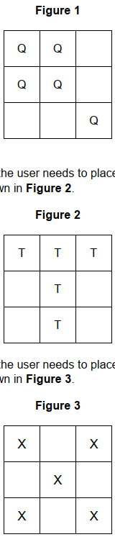
To score 10 points using the symbol T the user needs to place five T symbols in a 3×3 section of the grid so that they match the pattern shown in Figure 2.

To score 10 points using the symbol X the user needs to place five X symbols in a 3×3 section of the grid so that they match the pattern shown in Figure 3.


When the user has successfully created one of the allowed patterns within a 3×3 section of the grid, they are no longer allowed to place the symbol used in that pattern in any of the other cells in that 3×3 section. However, other symbols can still be placed in empty cells within that 3×3 section.
Some cells are blocked, denoted by the symbol @. The user is not able to place a symbol in a blocked cell. In the standard puzzle, the number of blocked cells and the position of each blocked cell is generated randomly.
An example of a starting grid for the standard puzzle is shown in Figure 4.
The row and column numbers have been shown. The cell in the bottom right corner of the grid is row 1, column 8.

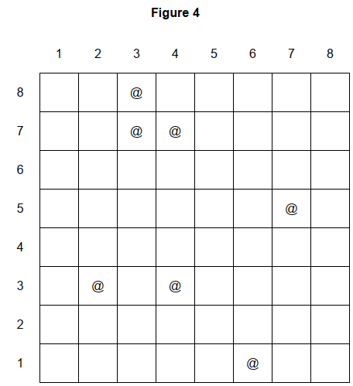

Instead of using the standard puzzle, the user may enter the name of a file containing a puzzle. Four text files containing different 5×5 grid puzzles have been provided: puzzle1, puzzle2, puzzle3 and puzzle4.
There are errors in the implementation of the puzzle in the Skeleton Program, which means that it does not work in the way described in this Preliminary Material under all circumstances.

Code
'Skeleton Program code for the AQA A Level Paper 1 Summer 2024 examination  'this code should be used in conjunction with the Preliminary Material  'written by the AQA Programmer Team  'developed in the Visual Studio Community Edition programming environment  Imports System.IO  Module Module1  Dim Rng As New Random  Sub Main()  Dim Again As String = "y"  Dim Score As Integer  While Again = "y"  Console.Write("Press Enter to start a standard puzzle or enter name of file to load: ")  Dim Filename As String = Console.ReadLine()  Dim MyPuzzle As Puzzle  If Filename.Length > 0 Then  MyPuzzle = New Puzzle(Filename & ".txt")  Else  MyPuzzle = New Puzzle(8, Int(8 * 8 * 0.6))  End If  Score = MyPuzzle.AttemptPuzzle()  Console.WriteLine("Puzzle finished. Your score was: " & Score)  Console.Write("Do another puzzle? ")  Again = Console.ReadLine().ToLower()  End While  Console.ReadLine()  End Sub  Class Puzzle  Private Score As Integer  Private SymbolsLeft As Integer  Private GridSize As Integer  Private Grid As List(Of Cell)  Private AllowedPatterns As List(Of Pattern)  Private AllowedSymbols As List(Of String)  Sub New(Filename As String)  Grid = New List(Of Cell)  AllowedPatterns = New List(Of Pattern)  AllowedSymbols = New List(Of String)  LoadPuzzle(Filename)  End Sub  Sub New(Size As Integer, StartSymbols As Integer)  Score = 0  SymbolsLeft = StartSymbols  GridSize = Size  Grid = New List(Of Cell)  For Count = 1 To GridSize * GridSize  Dim C As Cell  If Rng.Next(1, 101) < 90 Then  C = New Cell()  Else  C = New BlockedCell()  End If  Grid.Add(C)  Next  AllowedPatterns = New List(Of Pattern)  AllowedSymbols = New List(Of String)  Dim QPattern As Pattern = New Pattern("Q", "QQ**Q**QQ")  AllowedPatterns.Add(QPattern)  AllowedSymbols.Add("Q")  Dim XPattern As Pattern = New Pattern("X", "X*X*X*X*X")  AllowedPatterns.Add(XPattern)  AllowedSymbols.Add("X")  Dim TPattern As Pattern = New Pattern("T", "TTT**T**T")  AllowedPatterns.Add(TPattern)  AllowedSymbols.Add("T")  End Sub  Private Sub LoadPuzzle(Filename As String)  Try  Using MyStream As New StreamReader(Filename)  Dim NoOfSymbols As Integer = MyStream.ReadLine()  For Count = 1 To NoOfSymbols  AllowedSymbols.Add(MyStream.ReadLine())  Next  Dim NoOfPatterns As Integer = MyStream.ReadLine()  For Count = 1 To NoOfPatterns  Dim Items As List(Of String) = MyStream.ReadLine().Split(",").ToList()  Dim P As Pattern = New Pattern(Items(0), Items(1))  AllowedPatterns.Add(P)  Next  GridSize = Convert.ToInt32(MyStream.ReadLine())  For Count = 1 To GridSize * GridSize  Dim C As Cell  Dim Items As List(Of String) = MyStream.ReadLine().Split(",").ToList()  If Items(0) = "@" Then  C = New BlockedCell()  Else  C = New Cell()  C.ChangeSymbolInCell(Items(0))  For CurrentSymbol = 1 To Items.Count - 1  C.AddToNotAllowedSymbols(Items(CurrentSymbol))  Next  End If  Grid.Add(C)  Next  Score = MyStream.ReadLine()  SymbolsLeft = MyStream.ReadLine()  End Using  Catch  Console.WriteLine("Puzzle not loaded")  End Try  End Sub  Public Overridable Function AttemptPuzzle() As Integer  Dim Finished As Boolean = False  While Not Finished  DisplayPuzzle()  Console.WriteLine("Current score: " & Score)  Dim Valid As Boolean = False  Dim Row As Integer = -1  While Not Valid  Console.Write("Enter row number: ")  Try  Row = Console.ReadLine()  Valid = True  Catch  End Try  End While  Dim Column As Integer = -1  Valid = False  While Not Valid  Console.Write("Enter column number: ")  Try  Column = Console.ReadLine()  Valid = True  Catch  End Try  End While  Dim Symbol As String = GetSymbolFromUser()  SymbolsLeft -= 1  Dim CurrentCell As Cell = GetCell(Row, Column)  If CurrentCell.CheckSymbolAllowed(Symbol) Then  CurrentCell.ChangeSymbolInCell(Symbol)  Dim AmountToAddToScore As Integer = CheckForMatchWithPattern(Row, Column)  If AmountToAddToScore > 0 Then  Score += AmountToAddToScore  End If  End If  If SymbolsLeft = 0 Then  Finished = True  End If  End While  Console.WriteLine()  DisplayPuzzle()  Console.WriteLine()  Return Score  End Function  Private Function GetCell(Row As Integer, Column As Integer) As Cell  Return Grid((GridSize - Row) * GridSize + Column - 1)  End Function  Public Overridable Function CheckForMatchWithPattern(Row As Integer, Column As Integer) As Integer  For StartRow = Row + 2 To Row Step -1  For StartColumn = Column - 2 To Column  Try  Dim PatternString As String = ""  PatternString &= GetCell(StartRow, StartColumn).GetSymbol()  PatternString &= GetCell(StartRow, StartColumn + 1).GetSymbol()  PatternString &= GetCell(StartRow, StartColumn + 2).GetSymbol()  PatternString &= GetCell(StartRow - 1, StartColumn + 2).GetSymbol()  PatternString &= GetCell(StartRow - 2, StartColumn + 2).GetSymbol()  PatternString &= GetCell(StartRow - 2, StartColumn + 1).GetSymbol()  PatternString &= GetCell(StartRow - 2, StartColumn).GetSymbol()  PatternString &= GetCell(StartRow - 1, StartColumn).GetSymbol()  PatternString &= GetCell(StartRow - 1, StartColumn + 1).GetSymbol()  For Each P In AllowedPatterns  Dim CurrentSymbol As String = GetCell(Row, Column).GetSymbol()  If P.MatchesPattern(PatternString, CurrentSymbol) Then  GetCell(StartRow, StartColumn).AddToNotAllowedSymbols(CurrentSymbol)  GetCell(StartRow, StartColumn + 1).AddToNotAllowedSymbols(CurrentSymbol)  GetCell(StartRow, StartColumn + 2).AddToNotAllowedSymbols(CurrentSymbol)  GetCell(StartRow - 1, StartColumn + 2).AddToNotAllowedSymbols(CurrentSymbol)  GetCell(StartRow - 2, StartColumn + 2).AddToNotAllowedSymbols(CurrentSymbol)  GetCell(StartRow - 2, StartColumn + 1).AddToNotAllowedSymbols(CurrentSymbol)  GetCell(StartRow - 2, StartColumn).AddToNotAllowedSymbols(CurrentSymbol)  GetCell(StartRow - 1, StartColumn).AddToNotAllowedSymbols(CurrentSymbol)  GetCell(StartRow - 1, StartColumn + 1).AddToNotAllowedSymbols(CurrentSymbol)  Return 10  End If  Next  Catch  End Try  Next  Next  Return 0  End Function  Private Function GetSymbolFromUser() As String  Dim Symbol As String = ""  While Not AllowedSymbols.Contains(Symbol)  Console.Write("Enter symbol: ")  Symbol = Console.ReadLine()  End While  Return Symbol  End Function  Private Function CreateHorizontalLine() As String  Dim Line As String = " "  For Count = 1 To GridSize * 2 + 1  Line = Line & "-"  Next  Return Line  End Function  Public Overridable Sub DisplayPuzzle()  Console.WriteLine()  If GridSize < 10 Then  Console.Write(" ")  For Count = 1 To GridSize  Console.Write(" " & Count)  Next  End If  Console.WriteLine()  Console.WriteLine(CreateHorizontalLine())  For Count = 0 To Grid.Count() - 1  If Count Mod GridSize = 0 And GridSize < 10 Then  Console.Write((GridSize - ((Count + 1) \ GridSize)) & " ")  End If  Console.Write("|" & Grid(Count).GetSymbol())  If (Count + 1) Mod GridSize = 0 Then  Console.WriteLine("|")  Console.WriteLine(CreateHorizontalLine())  End If  Next  End Sub  End Class  Class Pattern  Private Symbol As String  Private PatternSequence As String  Sub New(SymbolToUse As String, PatternString As String)  Symbol = SymbolToUse  PatternSequence = PatternString  End Sub  Public Overridable Function MatchesPattern(PatternString As String, SymbolPlaced As String) As Boolean  If SymbolPlaced <> Symbol Then  Return False  End If  For Count = 0 To PatternSequence.Length - 1  If PatternSequence(Count) = Symbol And PatternString(Count) <> Symbol Then  Return False  End If  Next  Return True  End Function  Public Overridable Function GetPatternSequence() As String  Return PatternSequence  End Function  End Class  Class Cell  Protected Symbol As String  Private SymbolsNotAllowed As List(Of String)  Sub New()  Symbol = ""  SymbolsNotAllowed = New List(Of String)  End Sub  Public Overridable Function GetSymbol() As String  If IsEmpty() Then  Return "-"  Else  Return Symbol  End If  End Function  Public Function IsEmpty() As Boolean  If Symbol.Length = 0 Then  Return True  Else  Return False  End If  End Function  Public Sub ChangeSymbolInCell(NewSymbol As String)  Symbol = NewSymbol  End Sub  Public Overridable Function CheckSymbolAllowed(SymbolToCheck As String) As Boolean  For Each Item In SymbolsNotAllowed  If Item = SymbolToCheck Then  Return False  End If  Next  Return True  End Function  Public Overridable Sub AddToNotAllowedSymbols(SymbolToAdd As String)  SymbolsNotAllowed.Add(SymbolToAdd)  End Sub  Public Overridable Sub UpdateCell()  End Sub  End Class  Class BlockedCell  Inherits Cell  Sub New()  MyBase.New()  Symbol = "@"  End Sub  Public Overrides Function CheckSymbolAllowed(SymbolToCheck As String) As Boolean  Return False  End Function  End Class  End Module | The Main subroutine sets up a game and continues to loop after each game until the player doesn’t enter “y”.  If the player types a puzzle name rather than pressing the Enter key, then a puzzle is loaded from the filename.  MyPuzzle is instantiated in this subroutine as New Puzzle, calling the constructor method (Sub New) of the Puzzle class.  Grid represents a one-dimensional list of Cell objects, which makes up the board. AllowedPatterns is a one-dimensional list of Pattern objects which describe patterns which can be made within the game. AllowedSymbols is a one-dimensional list of String objects which can be played in the game.  You’ll notice two constructor methods in Puzzle (two methods labelled Sub New).  If a Puzzle is called with a filename, e.g.  New Puzzle(Filename & ".txt")  then the subroutine:  New(Filename As String)  is called  If however a Puzzle is called without a filename, e.g.  New Puzzle(8, Int(8 * 8 * 0.6))  then the subroutine:  New(Size As Integer, StartSymbols As Integer)  is called instead.  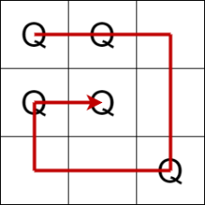 Patterns in the code are represented as a spiral. The 3x3 grid to the left represents the Pattern: QQ**Q**QQ  An example Puzzle file (puzzle1) is as follows, with relevant lines explained further where necessary.  3 Number of symbols in the game  Q Symbol 1  T Symbol 2  X Symbol 3  3 Number of patterns in the game  Q,QQ**Q**QQ Pattern description for ‘Q’  X,X*X*X*X*X Pattern description for ‘X’  T,TTT**T**T Pattern description for ‘T’  5 Size of the grid in the game  Q,Q --------------------------------------------  Q,Q  @,Q  ,  ,  Q,Q  Q,Q  ,Q  ,  ,  , These lines describe which  X,Q symbol goes in each cell  Q,Q (working from left to right, top row  X, to bottom row) followed by a  , comma, followed by any symbol  , which cannot be placed into that  , cell.  X,  ,  ,  ,  X,  ,  ,  , --------------------------------------------  10 Start score  1 Number of symbols to place  The AttemptPuzzle function takes a row, column, and Symbol from the player (validated using Try-Catch).  If the Symbol entered is valid in the Cell (checked with CheckSymbolAllowed), the score is adjusted and the Symbol is placed.  If there are no Symbols left to place, the game is Finished and the While loop concludes.  The Grid data structure is actually a one-dimensional list:  Private Grid As List(Of Cell)  Which means that for it to be considered a two-dimensional board, we need to calculate where in the list the Cell will be based on its Row and Column. That’s what the GetCell function is used for.  CheckForMatchWithPattern is an overridable function – meaning that any children of the Puzzle class could override the behaviour of this routine.  The CheckForMatchWithPattern function simply takes a Row and Column, and checks to see if the surrounding Cells make up a recognised pattern.  It generates a string from the surrounding cells, e.g.  QQ**Q**QQ  and then looks to see if this matches the patterns allowed with the MatchesPattern function.  If a matching pattern is found, it will add the CurrentSymbol to the surrounding Cell’s disallowed symbol list using AddToNotAllowedSybmols, and return a score of 10. If a matching pattern is not found, a score of 0 is returned.  GetSymbolFromUser simply gets an input string from the player, validating that what is entered is an allowed symbol in the game using:  While Not AllowedSymbols.Contains(Symbol)  CreateHorizontalLine and DisplayPuzzle are simply methods used to generate the Grid for display in a two-dimensional format in the Console window.  Recall that the Grid data structure is actually a one-dimensional list:  Private Grid As List(Of Cell)  The Mod function is used to calculate when to go to the next line etc., indexing the correct Grid position for the current count.  Mod recap  The Mod operator divides two numbers and returns only the remainder.  result = number1 Mod number2  The result is the remainder after number1 is divided by number2. For example, the expression 14 Mod 4 evaluates to 2 (14 divided by 4 is 3 remainder 2).  The Pattern class exists so that we can create Pattern objects.  Each Pattern object has a symbol, and a sequence – both stored as private variables, and passed as arguments into the Sub New when instantiated.  The MatchesPattern routine is used to check whether a PatternString (passed as an argument) and the SymbolPlaced by the player (also passed as an argument) are valid for that particular Pattern object.  GetPatternSequence is a public function we can use to access the private PatternSequence from outside of the class.  Each Cell object has an associated symbol (as a protected variable)  Protected means the variable can be accessed by children classes – which is useful because on the next page you’ll see BlockedCell inherits from Cell, and makes use of the Symbol variable.  GetSymbol simply returns the private Symbol string so we can see what’s inside the Cell (if the Cell is not empty).  IsEmpty returns whether the Cell is empty or not.  ChangeSymbolInCell replaces the current Symbol string with a NewSymbol string.  CheckSymbolAllowed will determine whether the symbol string being checked is a valid symbol for that Cell.  AddToNotAllowedSymbols allows us to add symbols to the disallowed symbols list.  UpdateCell does nothing in the Cell class, but utilises polymorphism by being overridable. It is likely we will be asked to do something with UpdateCell in the examination (either in Cell or BlockedCell and use Overrides).  BlockedCell inherits the protected and public attributes and methods from Cell.  MyBase.New is called to create a new Cell object, and the Symbol is set to @.  CheckSymbolAllowed overrides the behaviour of CheckSymbolAllowed in Cell such that if it is a BlockedCell, it always returns False.

Text Files
See page 6 for text file structure.
puzzle1.txt  3  Q  T  X  3  Q,QQ**Q**QQ  X,X*X*X*X*X  T,TTT**T**T  5  Q,Q  Q,Q  @,Q  ,  ,  Q,Q  Q,Q  ,Q  ,  ,  ,  X,Q  Q,Q  X,  ,  ,  ,  X,  ,  ,  ,  X,  ,  ,  ,  10  1 | puzzle2.txt  3  Q  T  X  3  Q,QQ**Q**QQ  X,X*X*X*X*X  T,TTT**T**T  5  Q,Q  Q,Q  @,Q  ,  ,  Q,Q  Q,Q  ,Q  ,  ,  ,  X,Q  Q,Q  X,  ,  ,  ,  X,  ,  ,  Q,  X,  ,  ,  T,  10  3 | puzzle3.txt  3  Q  T  X  3  Q,QQ**Q**QQ  X,X*X*X*X*X  T,TTT**T**T  5  Q,Q  Q,Q  @,Q  ,  ,  Q,Q  Q,Q  ,Q  ,  ,  ,  X,Q  Q,Q  X,  ,  ,  ,  X,  ,  ,  Q,  X,  ,  ,  T,  10  10 | puzzle4.txt  3  Q  T  X  3  Q,QQ**Q**QQ  X,X*X*X*X*X  T,TTT**T**T  5  ,X,Q  ,  @,  ,  ,  ,  ,  ,  ,  ,  ,  @,  ,  ,  ,  ,  ,  ,  @  ,  ,  ,  ,  ,  ,  0  30

